|  |  |  |  |  |
| --- | --- | --- | --- | --- |
| EGC_Black | | Mathematics Essentials 2016  Units 1/2 Test 2  Task Weighting: 5% | | |
| Student Name: |  | |  |

Time Allowed: 50 Minutes Total Marks: 45

**Calculators and files are allowed in this test.**

***Answer all of the following questions. Show all working to maximise marks.***

**Question 1** [3 Marks: 1, 2]

1. Which is the correct abbreviation for 25 centimetres?

25 cms or 25 cm (circle the correct answer)

1. Which unit, millimetre, centimetre, metre or kilometre, would you use to measure each of these lengths? Use the correct abbreviations for your answers.
2. The length of your calculator \_\_\_\_\_\_\_\_\_\_\_\_\_\_\_
3. The width of a postage stamp \_\_\_\_\_\_\_\_\_\_\_\_\_\_\_
4. The length of a cricket pitch \_\_\_\_\_\_\_\_\_\_\_\_\_\_\_
5. The distance from Kalgoorlie to Perth \_\_\_\_\_\_\_\_\_\_\_\_\_\_\_

**Question 2** [9 marks: 1, 1, 1, 1, 1, 1, 1, 2]

Complete the missing sections.

a) 3 m = \_\_\_\_\_\_\_\_\_\_ cm b) 5.35 km = \_\_\_\_\_\_\_\_\_ m

c) 4000 m = \_\_\_\_\_\_\_\_km d) 23 cm = \_\_\_\_\_\_\_\_\_\_\_\_mm

e) 360 sec = \_\_\_\_\_\_\_\_ min f) 168 hr = \_\_\_\_\_\_\_\_\_ day

g) 2 cm2 = \_\_\_\_\_\_\_\_ mm2 h) 30 km/hr = \_\_\_\_\_\_\_\_\_\_ m/min

**Question 3** [2 marks]

Katie is travelling to Esperence which is 450 km away. Katie is travelling in her car at 105 km/hr. How long will it take Katie to travel to Esperence? (Show working)

**Question 4** [8 marks: 3, 5]

(a)Kylie has a 5 m long piece of lace which she is going to use to put around the outside of 4 handkerchiefs. She will need 120 cm for each handkerchief. How much lace will be left when Kylie is finished? (Show working)

(b)Calculate the perimeters of these shapes. (Show working)

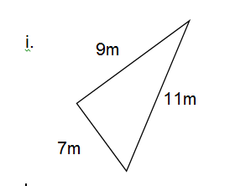 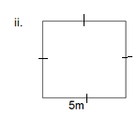

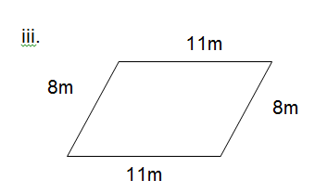 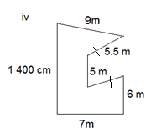

### Question 5 [3 marks: 1, 2]

Joe wants to put new carpet in his bedroom. His bedroom is 4.5 m long and 3.2 m wide.

1. Draw a diagram of Joe’s bedroom floor with dimensions.
2. How many square metres of carpet does Joe need to purchase in order to cover his bedroom? (show working)

### Question 6 [2 marks: 1, 1]

1. Estimate the **area** of the following shape. Each square represents 1 unit2.

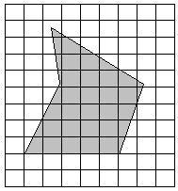

\_\_\_\_\_\_\_\_\_\_\_\_\_\_\_\_\_\_\_\_\_\_\_\_\_

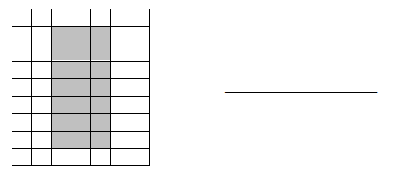(b) Calculate the **area** of the following shape. Each square represents 1 unit2.

**Question 7** [7 marks: 2, 2, 3]

Calculate the area of the following shapes:

(Show working)

a) b)

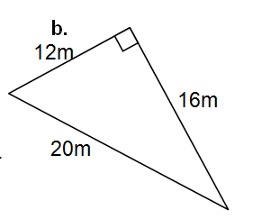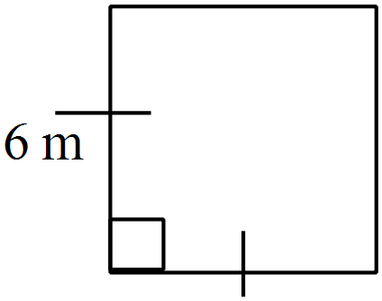

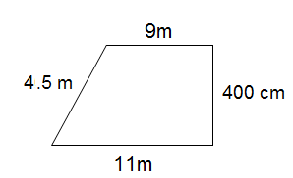

c)

**Question 8** [4 marks: 2, 2]

1. John plays cricket. If John can bowl 6 balls in 5 minutes. How many balls can he bowl  
    in ½ hour?
2. At Coles you have a choice of buying loose potatoes or a bag of potatoes. Loose potatoes cost $2.30 /kg and a 3 kg bag of potatoes is $7. Which is the better buy **and explain** how you reached your answer?

### Question 9 [7 marks: 2, 2, 3]

This is the position of Grant’s house on his block of land.

85m

30m

65m

Back Yard

House

Driveway

Carport

a)The block of land is 30 m wide and 85 m long. What is the area of the block of land?

b)The land is valued at $95 per square metre. Calculate the value of the block of land.

c)The grass in the back yard needs fertilising. One bag of fertiliser covers 650 m2. Will one bag be enough for Grant’s back yard?

Give a reason for your answer.

**END OF TEST**